1. Create one VPC,with 1 one public sub-net and 1 private sub-net.  
     
     
   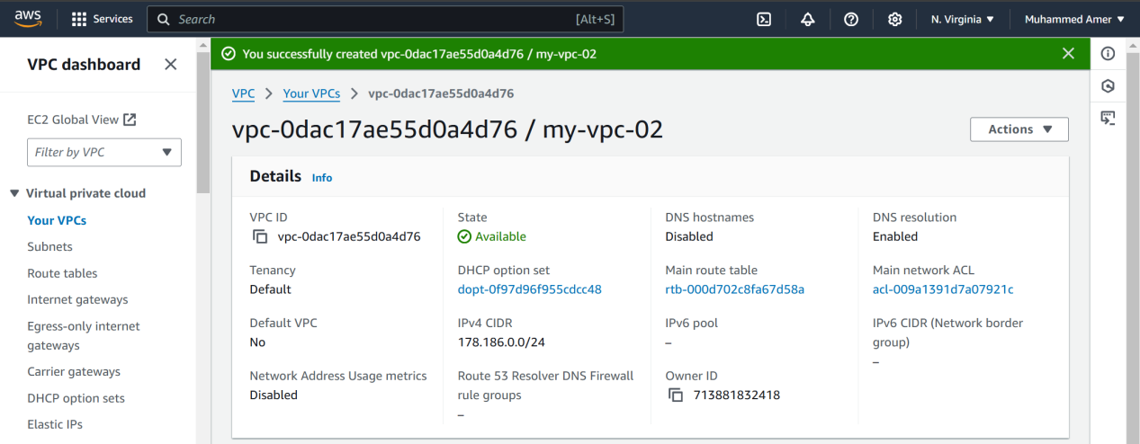  
     
     
     
     
     
   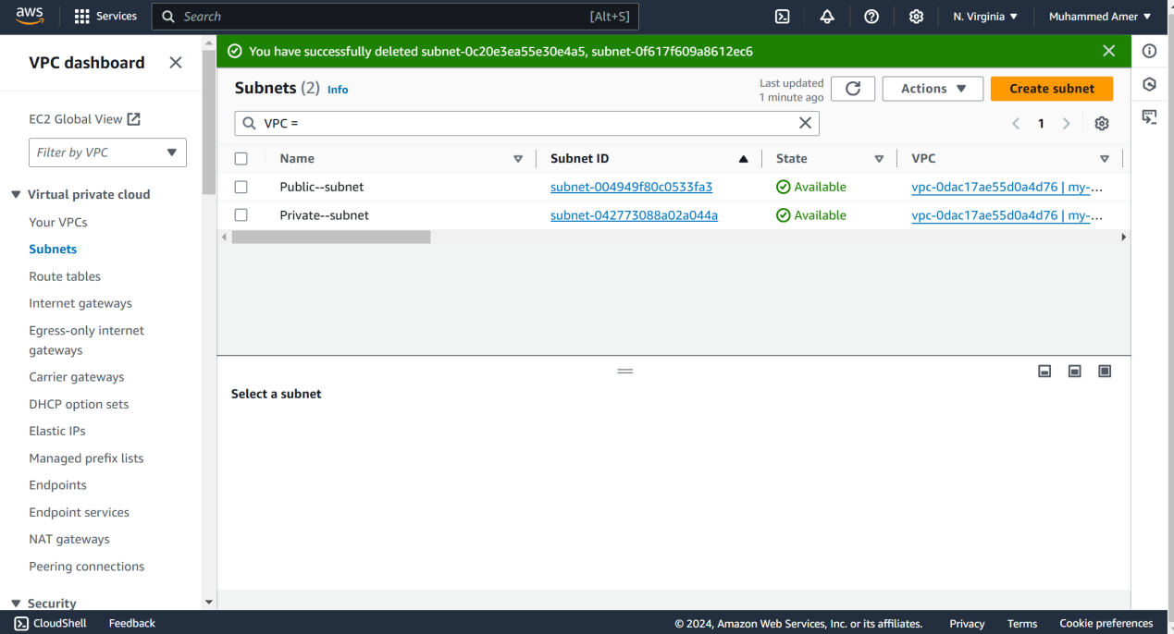  
     
     
     
     
     
     
     
     
     
     
     
     
     
   2) Enable VPC peering for cross region.   
     
   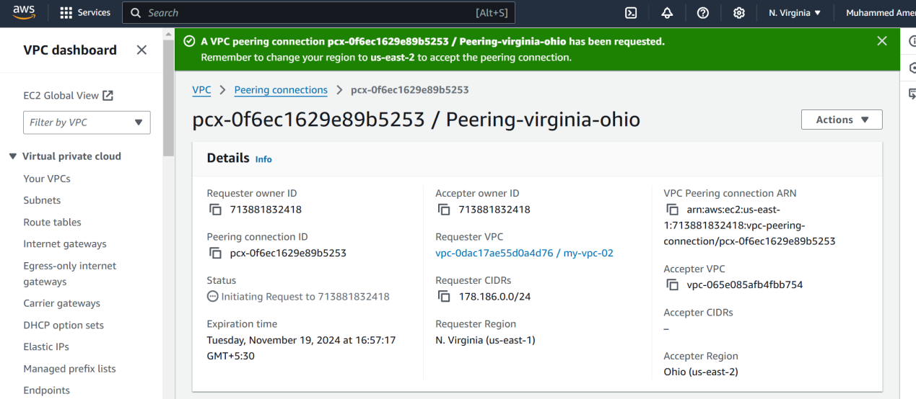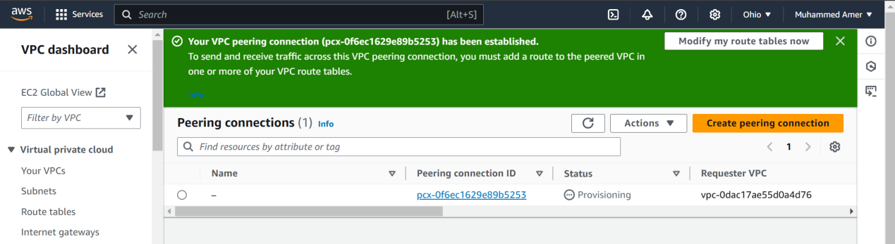  
   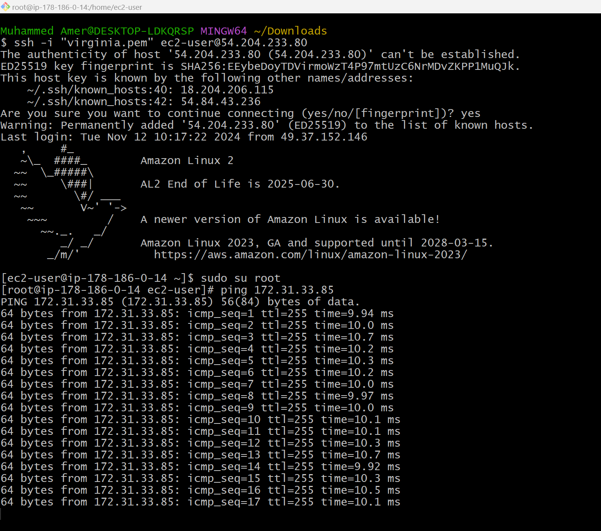  
   3) Enable VPC peering for cross account. (You can collaborate with your friend and do this task).  
     
     
     
   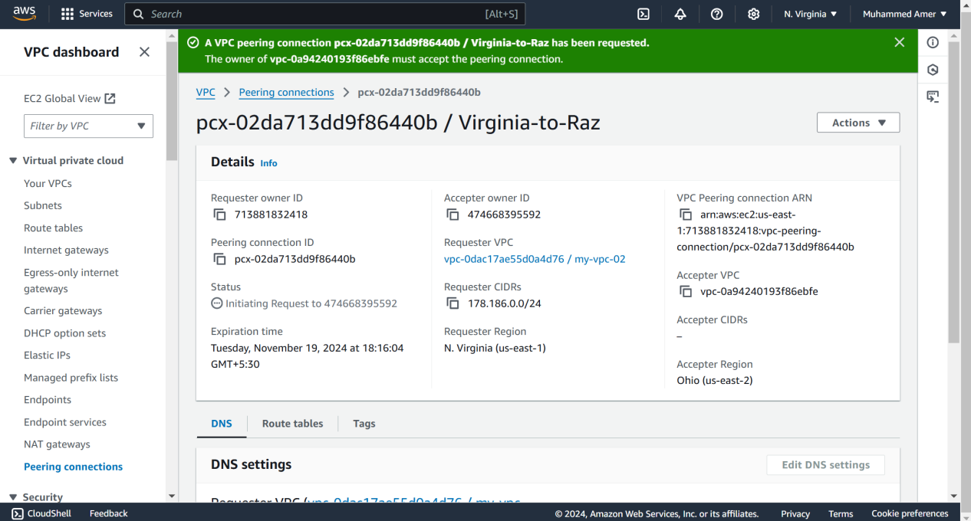  
     
     
     
   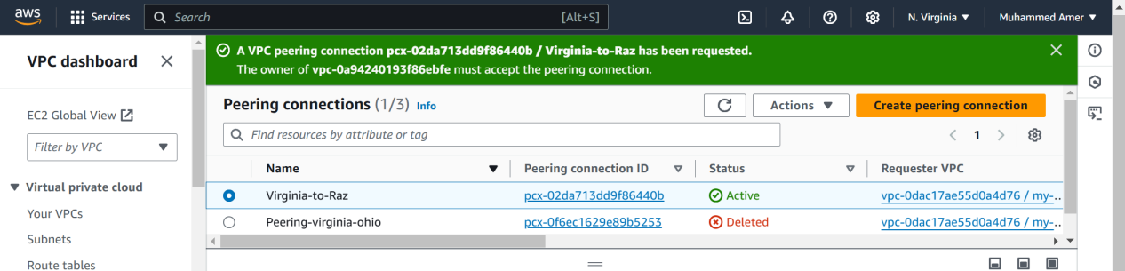  
     
     
     
     
   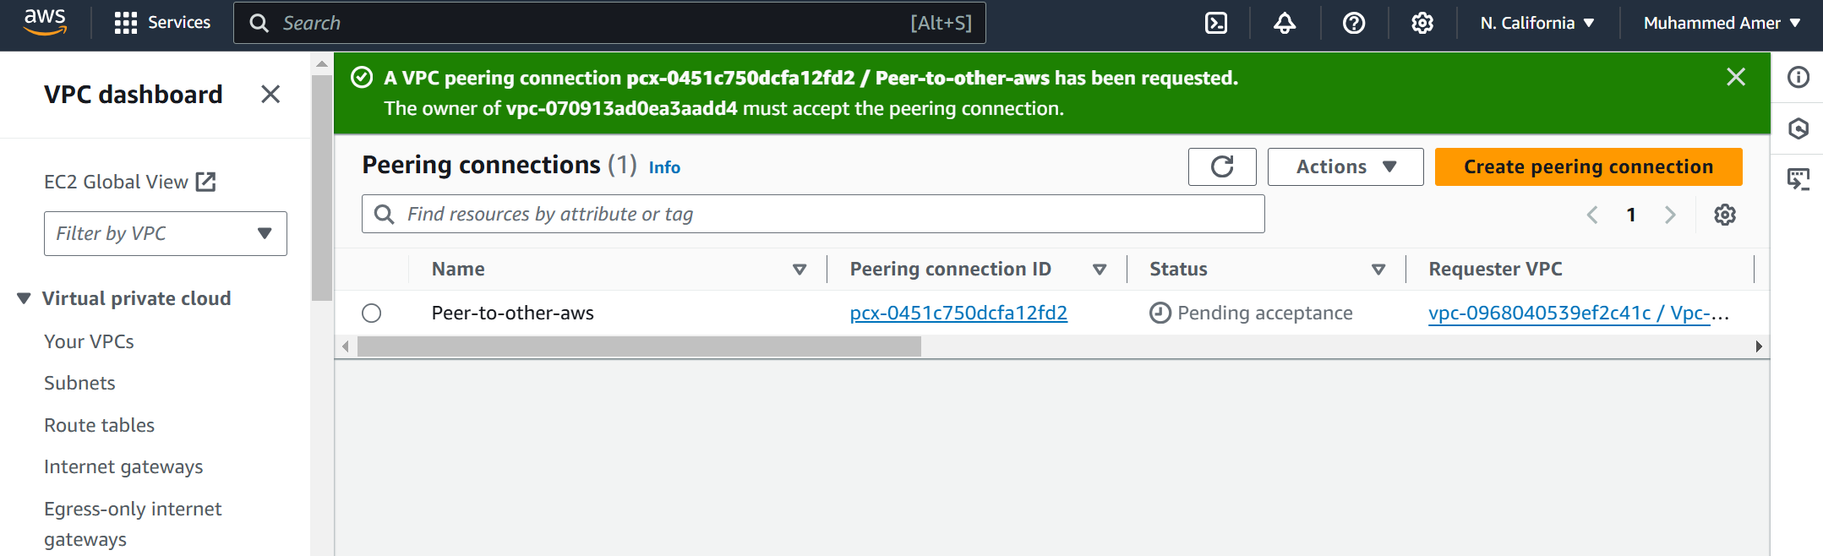  
     
     
     
     
     
     
     
   Connected to other account private ip  
     
   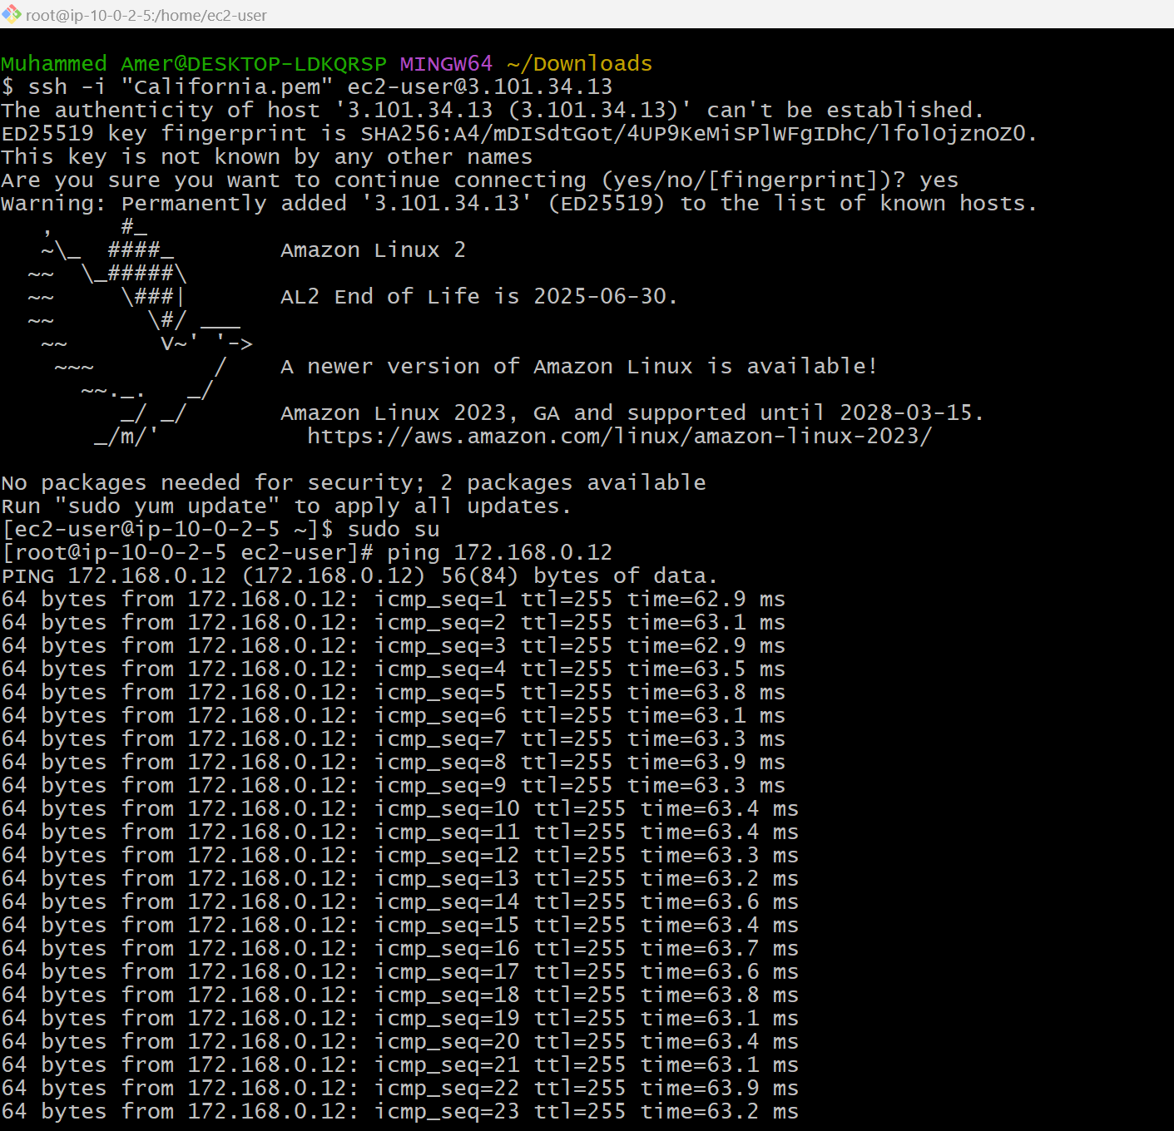  
     
     
     
     
     
   4) Setup VPC Transits gateway.  
     
   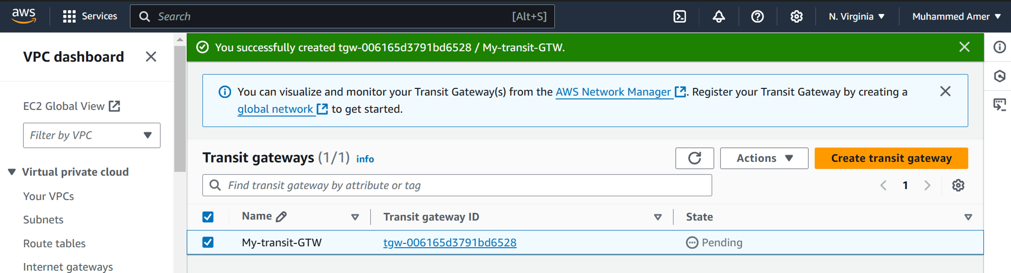

5) Setup VPC End Point  
  
